MINI PROJECT REPORT

on

**"Job Portal Web Application"**

By

Abhishek Shinde 119A3003

Prajyot Bhoir 119A3011

Dhanvi Mange 119A3013

UNDER THE GUIDANCE OF

**Prof. - Seema Redekar**

SUBMITTED IN PARTIAL FULFILLMENT FOR THE DEGREE OF

BACHELOR OF ENGINEERING

In

Information Technology



**DEPARTMENT OF INFORMATION AND TECHNOLOGY**

**SIES GRADUATE SCHOOL OF TECHNOLOGY**

**NERUL, NAVI MUMBAI – 400706**

ACADEMIC YEAR

2020– 2021

**CERTIFICATE**

This is to certify that this is a bonafide record of Mini Project of the project titled **“Job Portal Web Application”** carried out by the following students of second year in Information Technology.

Sr. No. Name Roll No.

1. Abhishek Shinde 119A3003

2. Prajyot Bhoir 119A3011

3. Dhanvi Mange 119A3013

The report is submitted in partial fulfillment of the degree course of Bachelor of Engineering in Information Technology, of University of Mumbai during the academic year 2020-21

**Internal Guide Head of Department Principal**

We have examined this report as per University requirements at SIES Graduate School of Technology, Nerul (E), Navi Mumbai on ____________.

**Name of External Examiner: ___________________________________________**

**Signature with Date: _____________________________**

**Name of Internal Examiner: ___________________________________________**

**Signature with Date: _____________________________**

**ACKNOWLEDGEMENT**

We wish to express our deep sense of gratitude to thank our project guide prof. Seema Redekar for providing timely assistance to our query and guidance. We take this opportunity to thank our HOD Dr. K.Lakshmisudha and Principal Dr.Atul Kemkar for their valuable guidance and immense support in providing all the necessary facilities.

We would also like to thank the entire faculty of the IT Department for their valuable ideas and timely assistance in this project. Last but not the least, we would also like to thank teaching and nonteaching staff members of our college for their support in facilitating timely completion of the mini project.

**Abhishek Shinde -119A3003**

**Prajyot Bhoir -119A3011**

**Dhanvi Mange- 119A3013**

**CONTENTS**

|  |  |  |
| --- | --- | --- |
| Sr.No. | Topic | Page No. |
| I | Abstract | 5 |
| 1. | w Intro Introduction | 6 |
| 1.1 | Motivation | 6 |
| 1.2 | Problem Statement & Objectives | 6 |
| 2. | Literature Survey | 7 |
| 2.1 | Survey of existing System | 7 |
| 2.2 | Limitation Existing System or Research Gap | 7 |
| 3 | Proposed System | 8 |
| 3.1 | Introduction | 8 |
| 3.2 | Architecture /Framework | 9 |
| 3.3 | Process design | 9 |
| 3.4 | Details of hardware and software | 11 |
| 3.5 | Experiment Results | 11 |
| 4 | Future work for Sem V | 18 |
| 5 | Conclusion | 19 |
| 6 | References | 20 |

**ABSTRACT**

In this competitive era, the education among the people is so increasing that the jobs for them are now decreasing. The companies even want the people who are best in their fields. At that time, it becomes difficult to find the people who are intelligent enough to be hired. The work for the companies also increases to find the people who can fulfill their requirements. Thinking about these problems, one can think about the process which can handle this process and make the work less complex.

Finding jobs that best suits the interests and skill set is quite a challenging task for the job seekers. The difficulties arise from not having proper knowledge on the organization’s objective, their work culture and current job openings. In addition, finding the right candidate with desired qualifications to fill their current job openings is an important task for the recruiters of any organization. Online Job Search Portals have certainly made job seeking convenient on both sides. Job Portal is the solution where recruiter as well as the job seeker meet aiming at fulfilling their individual requirement. They are the cheapest as well as the fastest source of communication reaching a wide range of audience on just a single click irrespective of their geographical distance.

The web application “Job Hunt” provides an easy and convenient search application for the job seekers to find their desired jobs and for the recruiters to find the right candidate. Job seekers from any background can search for the current job openings. They can search for available jobs and apply to their desired positions.Company can register and post their current openings. They can view the Job applicants and can screen them according to the best fit. Users can provide a review about an organization and share their interview experience, which can be viewed by the Company and other Jobseekers.

**INTRODUCTION**

**Motivation:**

The purpose of developing an Online Job Search Portal comes from the idea to make the job search efficient and handy. It helps the recruiters as a primary source of talent search. It also helps the job seekers to search for current vacancies at a single point. Therefore, we can say that Online Job Search Portal acts as a bridge of communication between organizations and applicants. With the evolution of technology and the internet being the main source of information for the applicants, these job portals have become an excellent method to reach a wide range of audience. Initially, when we were unaware of these portals, we used to do research about companies and their technology stack through their respective websites and apply if the job responsibilities matched our interests. This requires lots of effort and time.

**Problem Statement:**

The system after careful analysis has been identified to be presented with the following modules :

Job Seeker :-

In this module Job Seeker will search for the available jobs and he can apply for the jobs by filling in the necessary details and uploading the resume. He/she will be able to add/view reviews about a particular company.

Job provider :-

In this module Job Provider registers himself /company and after login he can post the job. He also has access to update or delete a job which he might have posted in the past . He can offer the job to job seekers according to the job profile and he can also see the response from the job seekers and send the mail.He can view the reviews posted by the user and make necessary changes in the company.

**Objective:**

The objective of the Job Hunt Portal is to provide flexibility to the jobseekers by providing the functionalities of both job search and job application in a single application. In addition, this application provides an effective means for the employers to post jobs and view the job applications by the interested applicants in a single application. Employers can also view the reviews provided by the jobseekers. The main objective is to build a common platform that connects with jobseekers and job providers.

**LITERATURE SURVEY**

**Survey of existing System:**

|  |  |  |  |
| --- | --- | --- | --- |
| **Sr. no** | **Author** | **Title and Publication** | **Key Findings** |
| 1. | J. Dorn and T. Naz | “Integration of Job portals by Meta-search,” | Before the Internet became widely used as a method of seeking jobs, jobseekers spent a lot of time using various methods to look for job openings. |
| 2. | M. Mansourvar and N. Y. Mohd, | “Web portal as a knowledge management system in the universities,” | The Internet plays an important role in the area of human resource planning and development. Most planning and development organizations are now using computer technology and the Internet for staff recruitment. |

**Limitation of Existing System or Research Gap:**

i) Existing system are a failing in providing quick operation

ii) Cost is high as well.

iii) Processing is very lengthy and time consuming.

iv) It is very time consuming.

v) Stressful and a lot of manual work required.

vi) It is very challenging.

**PROPOSED SYSTEM**

**Introduction:**

The objective of the Job Hunt Portal is to provide flexibility to the jobseekers by providing the functionalities of both job search and job application in a single application. In addition, this application provides an effective means for the employers to post jobs and view the job applications by the interested applicants in a single application. Employers can also view the reviews provided by the jobseekers. The main objective is to build a common platform that connects with jobseekers and job providers.

1. With the advancement of technology job seekers are relying greatly on Online Job Search Portals.
2. In the proposed system we are trying to develop an online job search web application that reduces challenges for job seekers to find a desired and suitable job according to their qualification. We aim at reducing the challenges by providing advanced search features that gives the candidate ample scope to select jobs that matches their skill set and requirements and gives them back the exact jobs that are available.
3. This in turn is less time taking as the candidate gets all details in one place and does not have to go to the company website to learn about the positions. In the proposed system job seekers can upload their resumes in the required file format, see all the available jobs and search for desired jobs and then apply for those jobs.
4. On the other hand, this system enables employers to post their jobs and get a list of all applications which they can screen online and that reduces the huge amount of manual effort and time. Online recruitment or e-recruitment is turning out to be both the job seekers and the employers’ favorite activity as offer and demand are well met at one place and both must spend less time to get hold of the right roles or candidates.
5. The company can post jobs, see applications and check resumes in the proposed system.

**Architecture /Framework:**

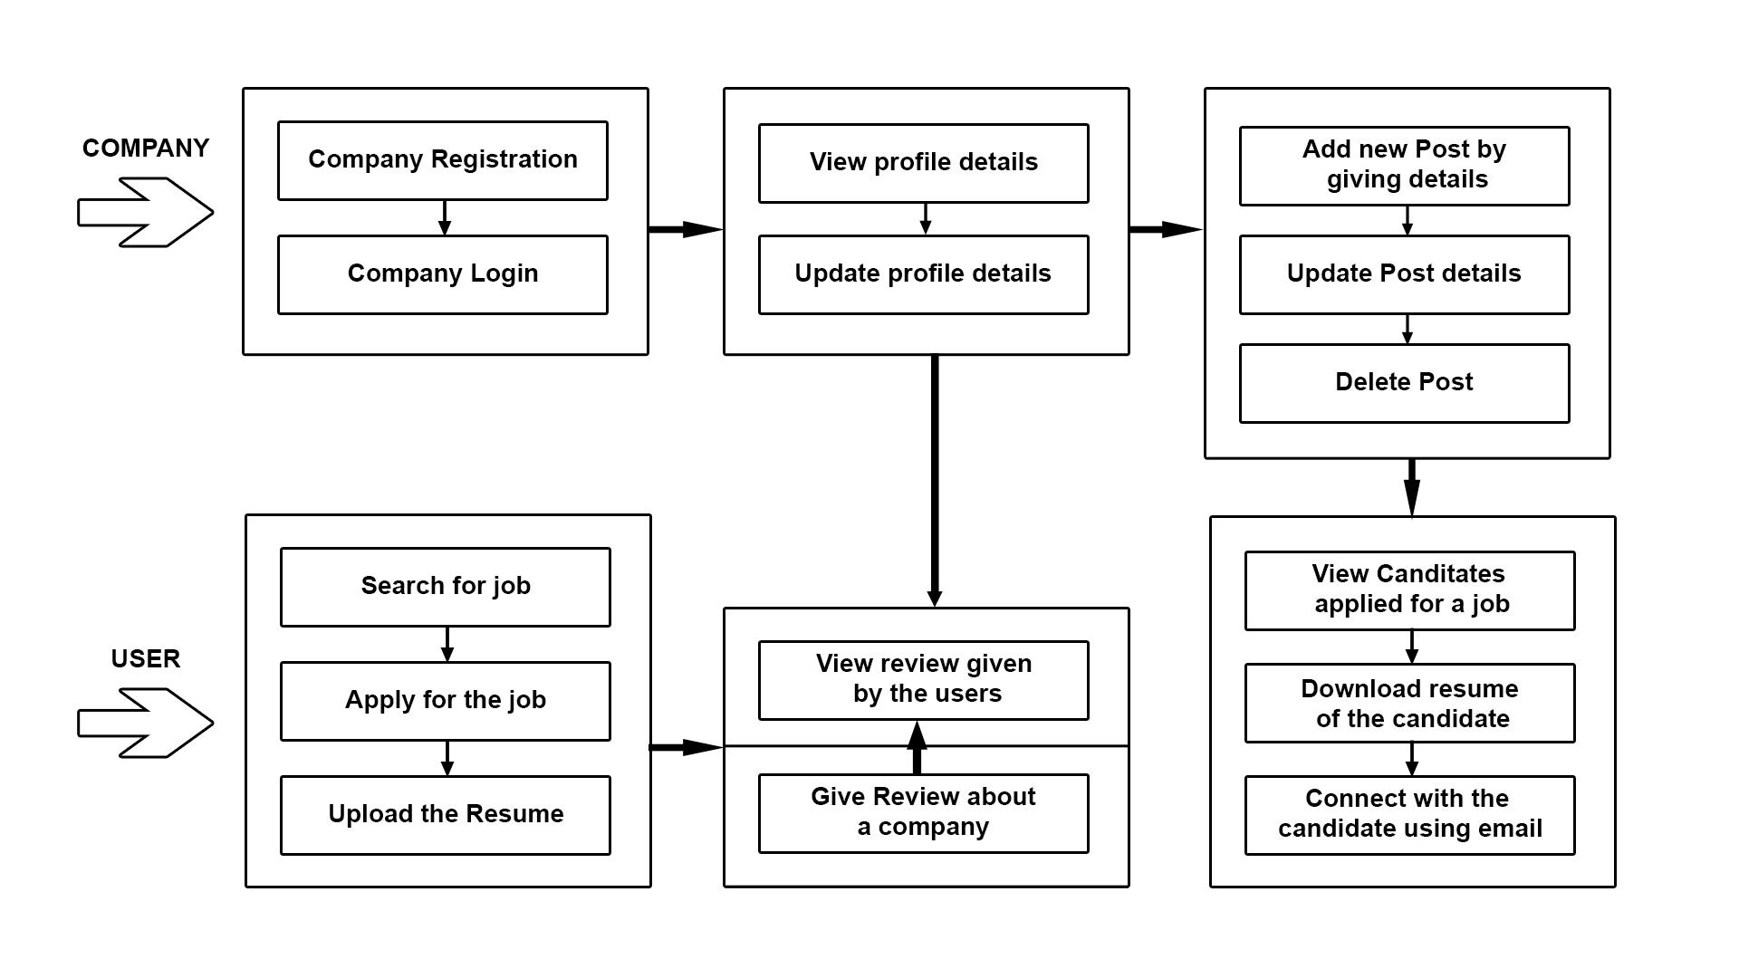

**Process Design:**

The proposed system has two major divisions. One is the jobseeker module and the other is the Company Module.

The Jobseeker- users will be able to perform functions such as search, view and apply for active job openings. All the applied jobs details are stored in the SQLite database. The applicants can also provide reviews for the companies.

Company- Company will be able to perform functions such as registering with the application and creating an account by providing the details of UserName, Company Email, and Password. Once the account is activated, this module allows employers to post jobs summarizing responsibilities and expected skills.. He/she can view the applicant details that have applied for a particular job posting. The employer will be able to view reviews provided by the jobseeker.

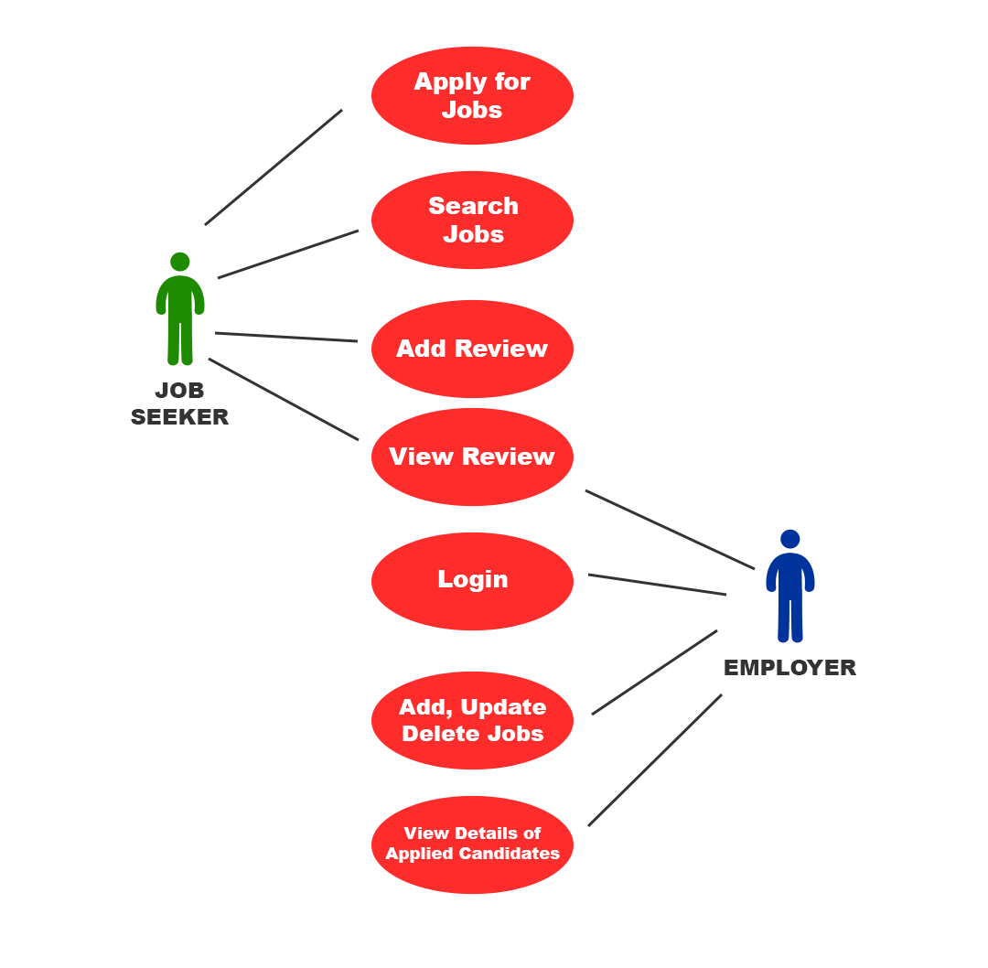

**Use Case Diagram**

Working- The working starts from the company module. The company registers itself and then creates a post with appropriate job details. The jobseeker can then apply for the job. He/she can also give reviews. The company can then view the candidates who have applied for the job. It can also view the reviews given by the users.

**Details of hardware and software:**

1. Database : SQLite
2. IDE :VS Code
3. Language: Python
4. Browser : Chrome
5. Operating System: Windows 7 and above

**Experiment Results:**

**Home Page:**

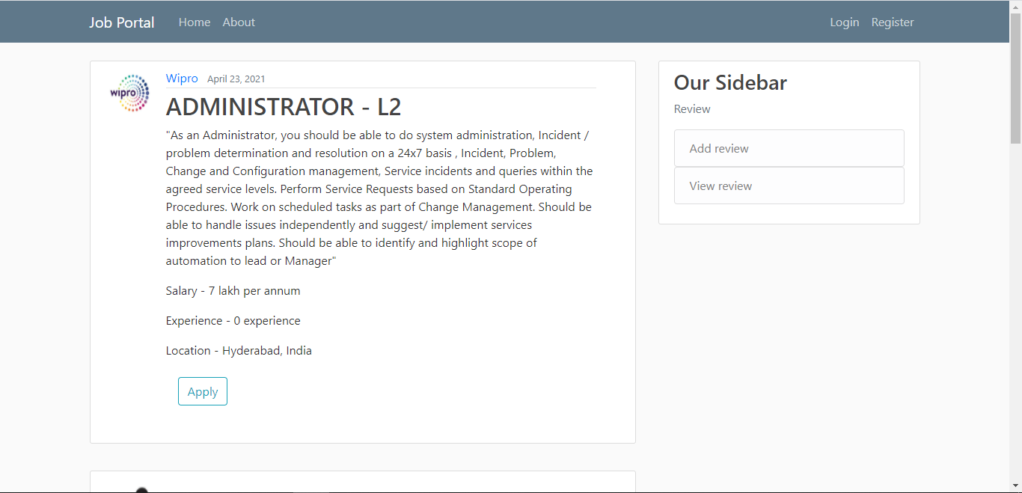

**Register Page:**

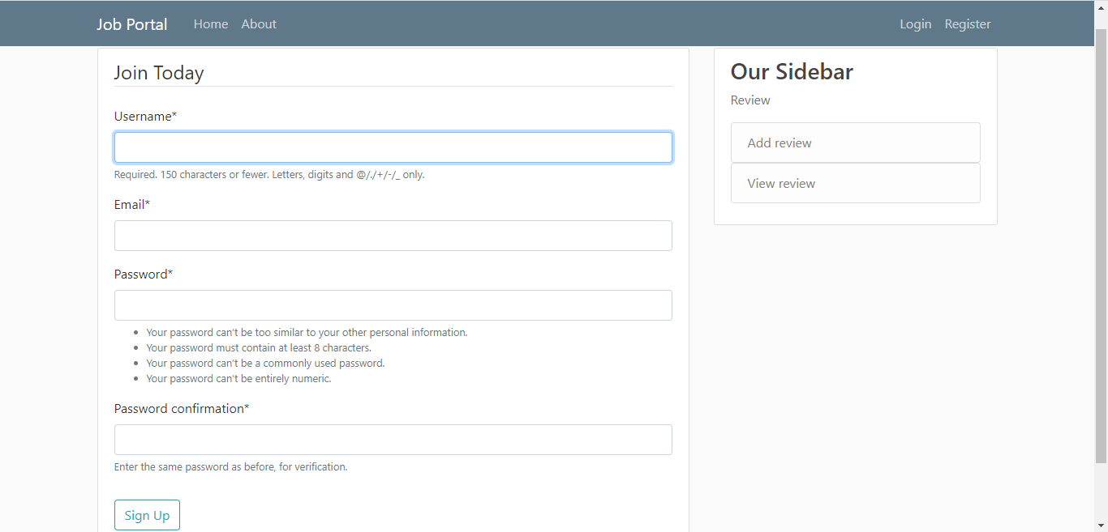

**Login Page:**

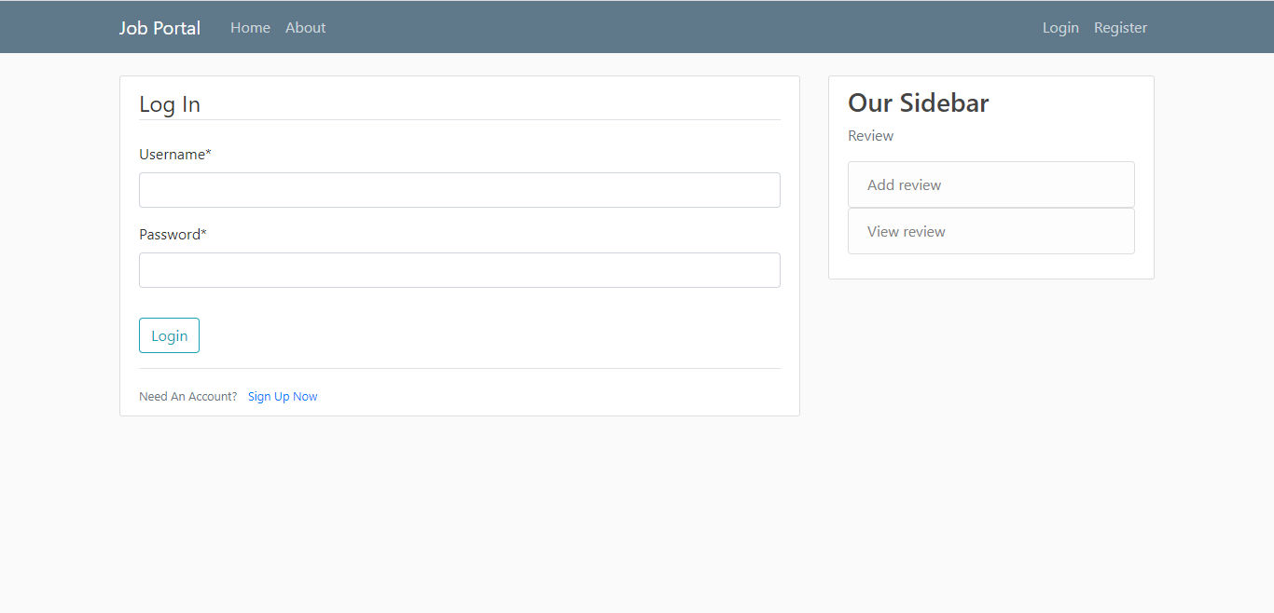

**About page:**

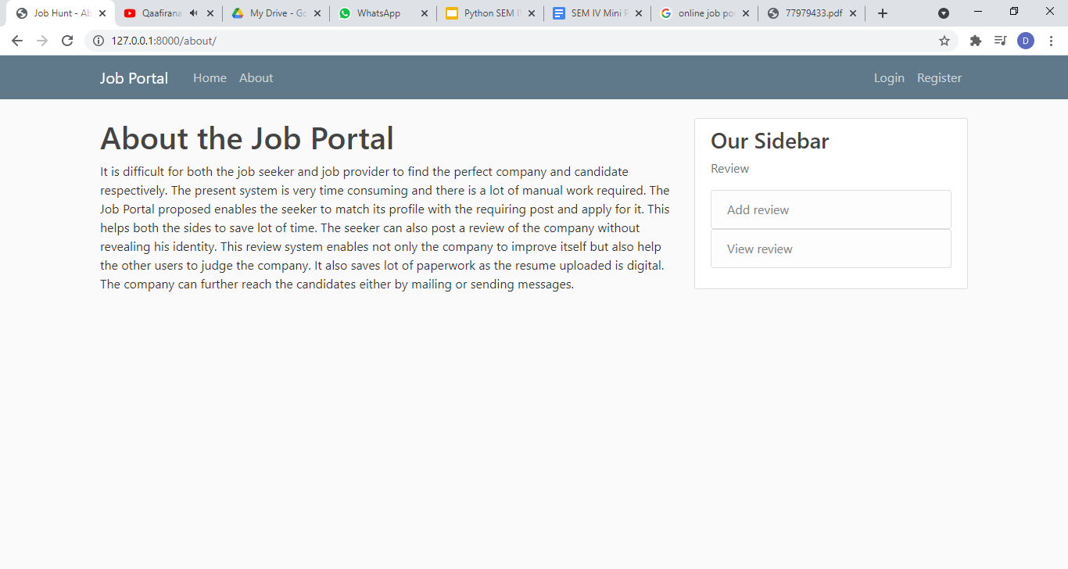

**Profile Page:**

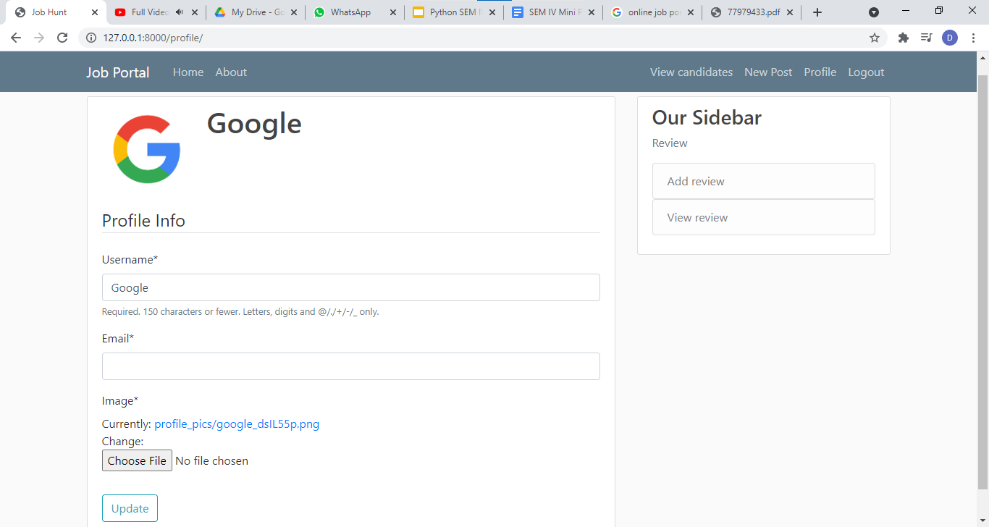

**New Post:**

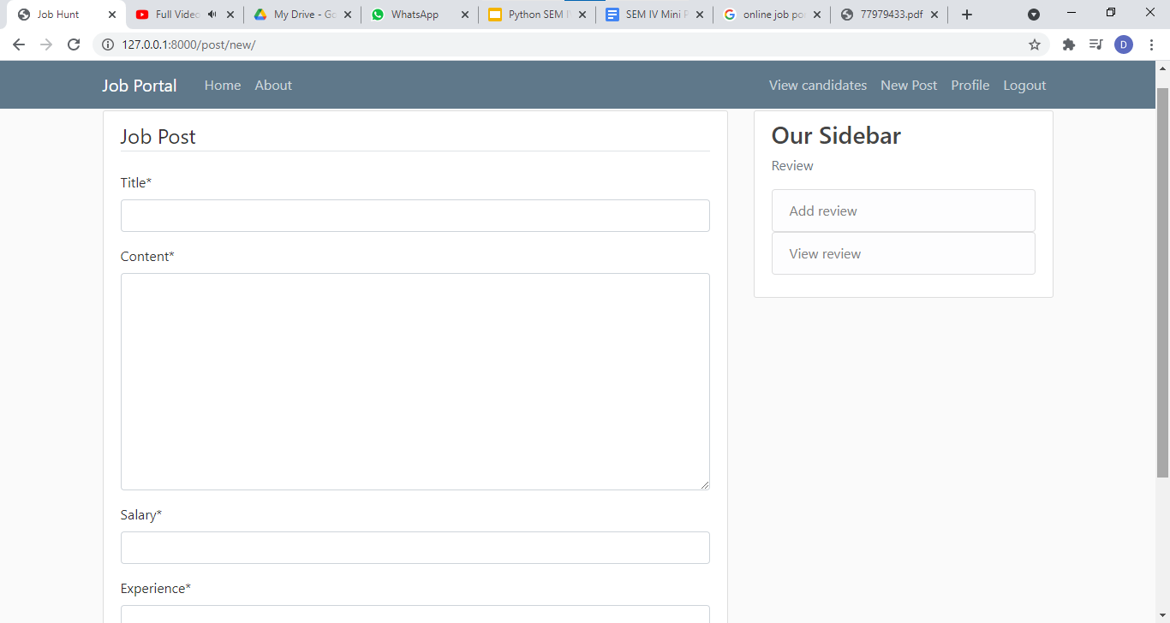

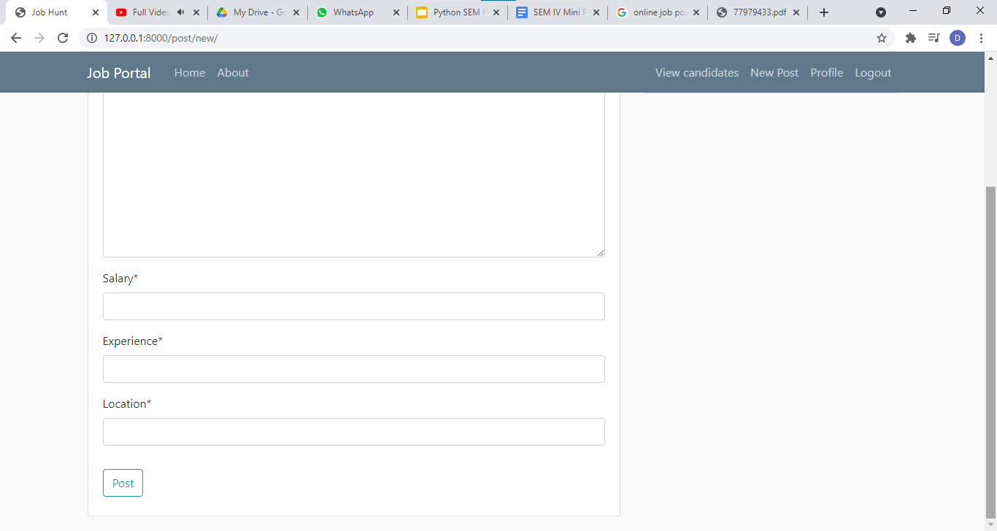

**Candidates apply:**

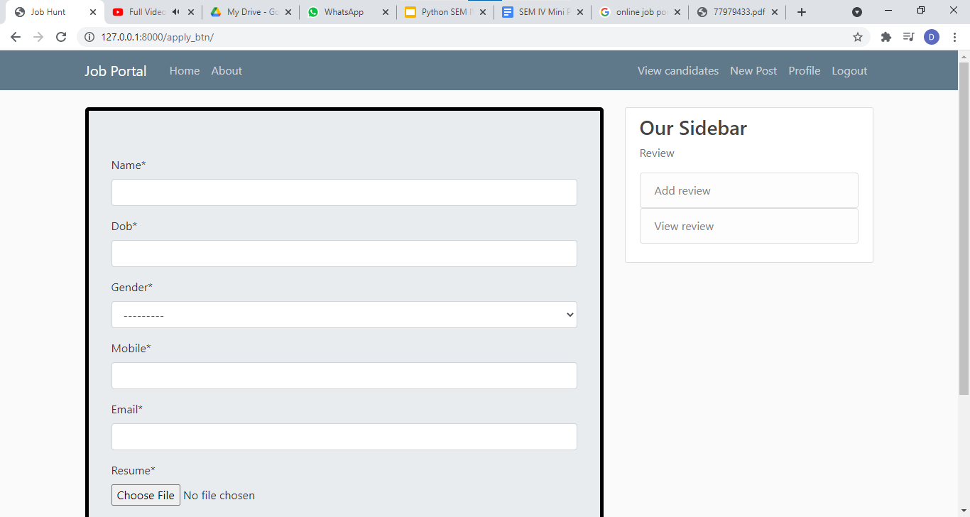

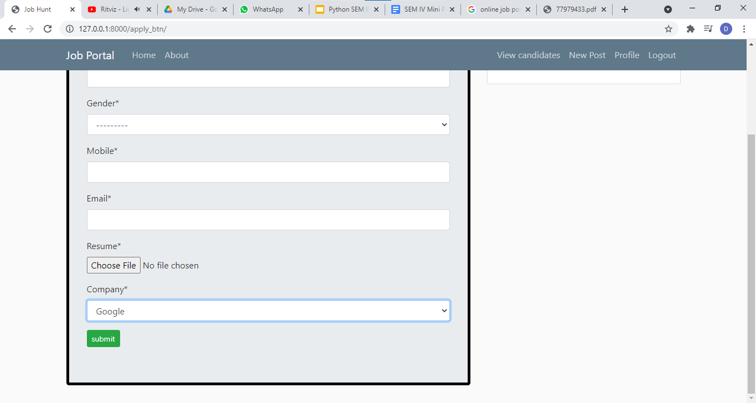

**View Candidates:**

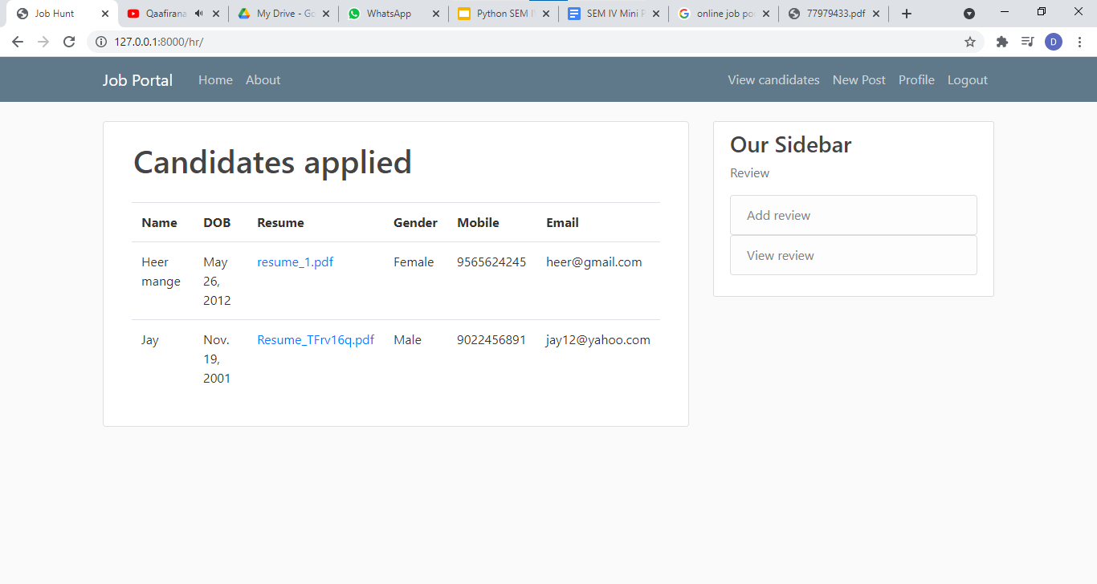

**Add Review:**

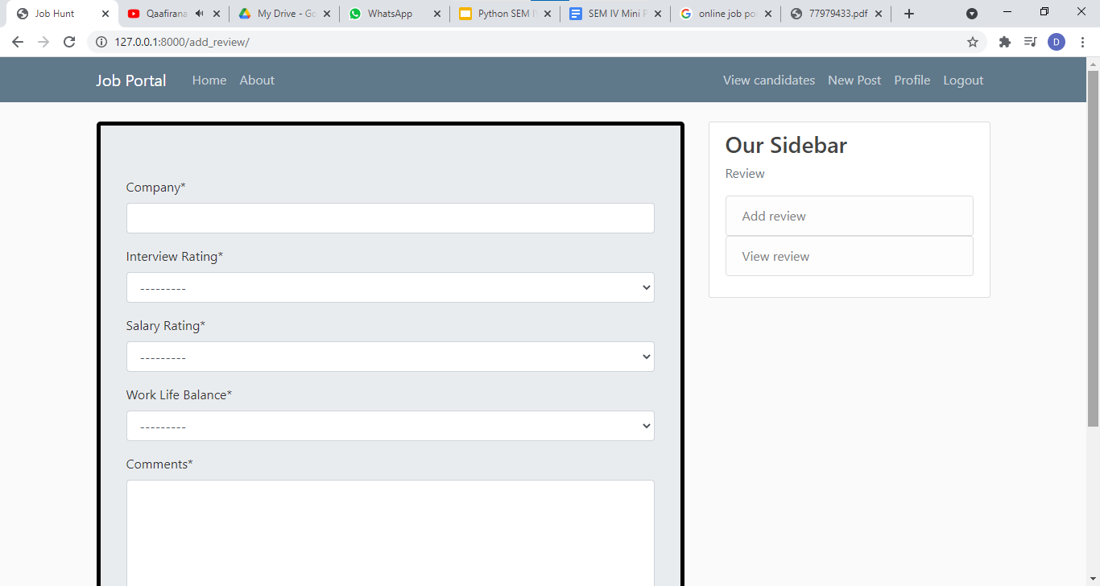

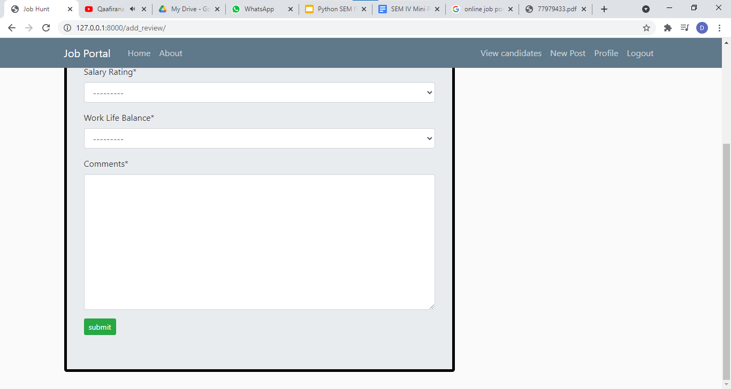

**View Review:**

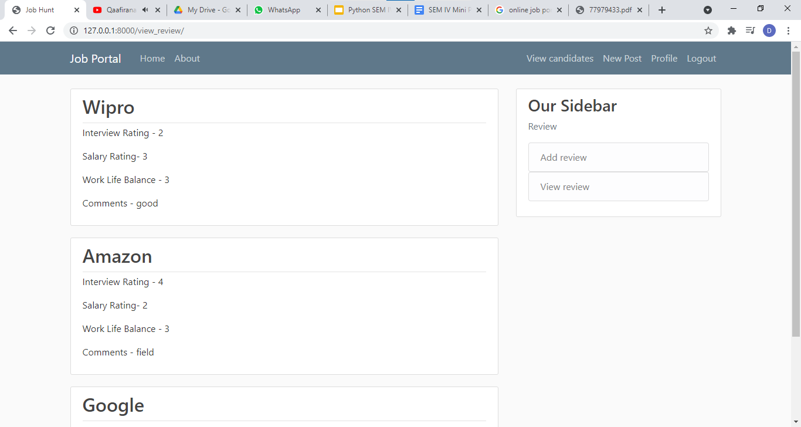

**FUTURE WORK FOR SEM V**

This project fulfills the primary requirements of the job seekers and employers. It can be extended in several ways – We can provide recommendations and email updates for new job postings based on the job seeker’s search history. Since, the job seekers might be interested in building a strong Resume, we can provide tips and information for the same. We can also provide templates for building the Resumes which might interest most applicants. We can also create accounts for the jobseeker and store its data. Recommendations can also be provided. An android Application can also be built.

**CONCLUSION**

Job Search Portals stands as a revolutionizing element in the sphere of recruitment. They act as a communication bridge between applicants and recruiters facilitating their requirements. This application helps organizations to have a greater exposure to the candidate pool and also job seekers facilitating wide search of jobs matching their interests. This application provides an enhanced user experience for both employer and jobseeker. It provides a user friendly interface which facilitates in reaching a wide range of audience. The application has achieved all the requirements that were initially set in the requirements gathering phase.

This project taught us some best practices in the technology stack like Django and Sqlite. Starting from requirements elicitation to design, construction, implementation and testing, we have gained a very good experience working with various technologies at every phase. Development of this project boosted our confidence in python programming.

**REFERENCES**

i) https://www.tutorialspoint.com/index.htm

ii) www.w3school.com

iii)https://www.youtube.com/watch?v=3aVqWaLjqS4&list=PLosiE80TeTtoQCKZ03TU5fNfx2UY6U4p&index=9

iv) https://developer.mozilla.org/en-US/docs/Learn/Server-side/Django

v) https://stackoverflow.com/questions/tagged/django